**ASSIGNMENT 33.1**

QUESTION 1 : Create the method name get record and use get class to retrieve one record at a time record from company table.

Step 1: write a java code to get only names from the table ‘custom1’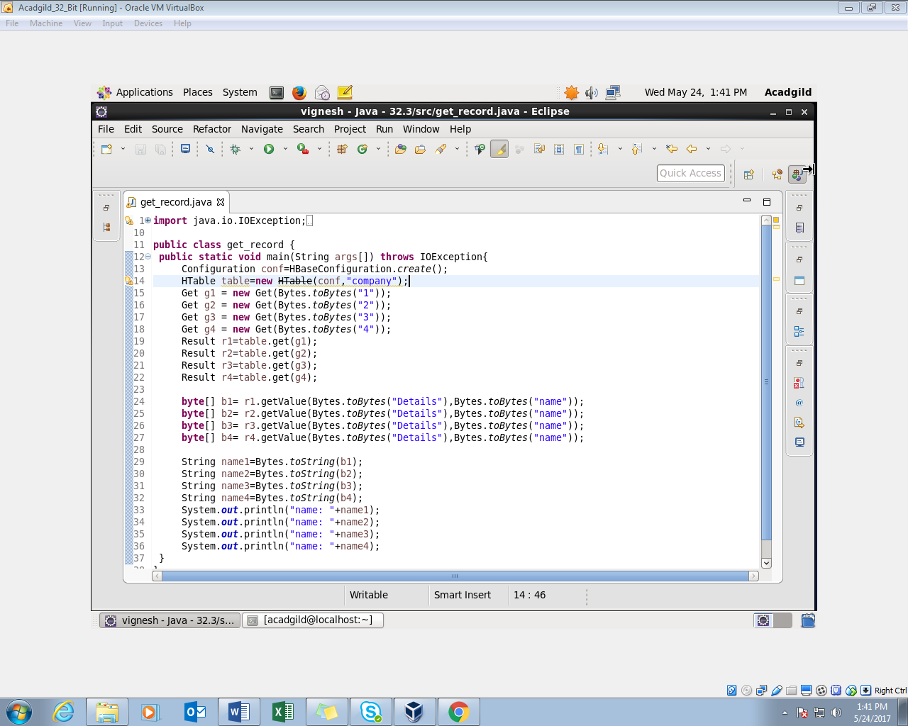

Step 2: Run the program to list of names from the table ‘custom1’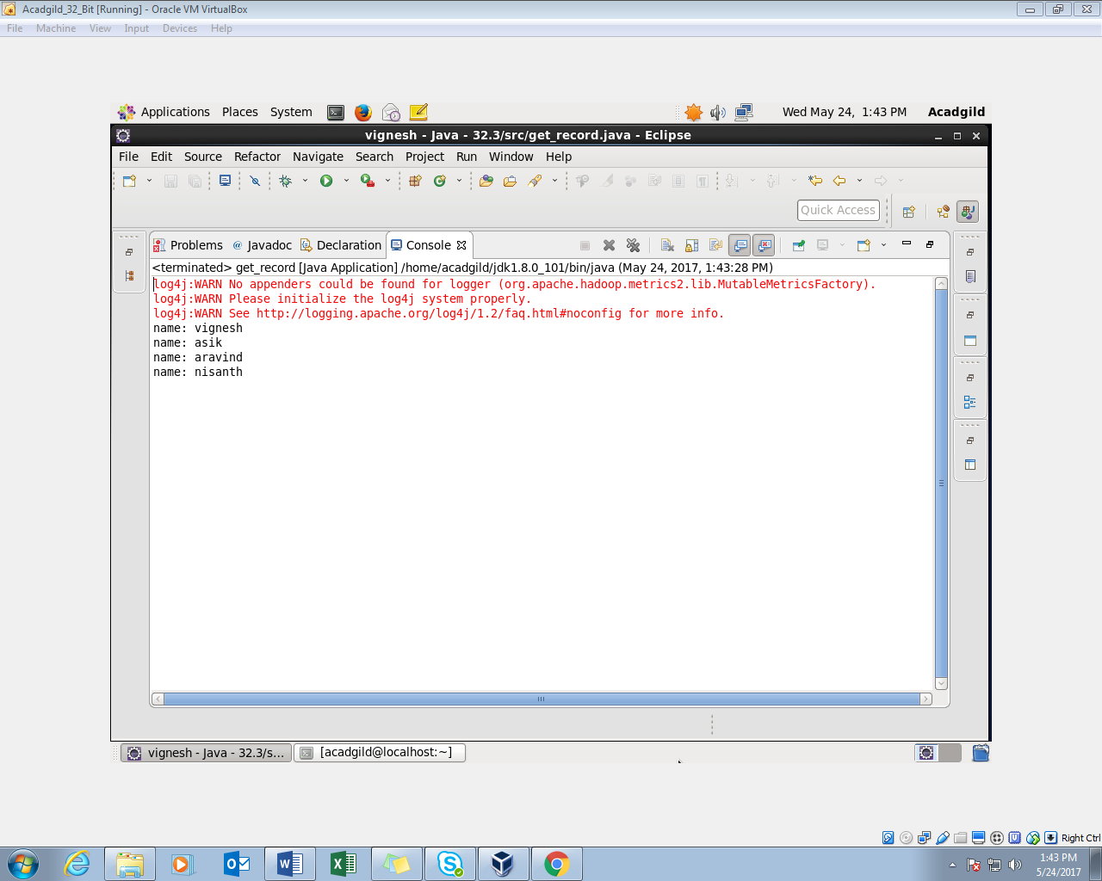

Step 3: check the contents of the table “company” using scan command

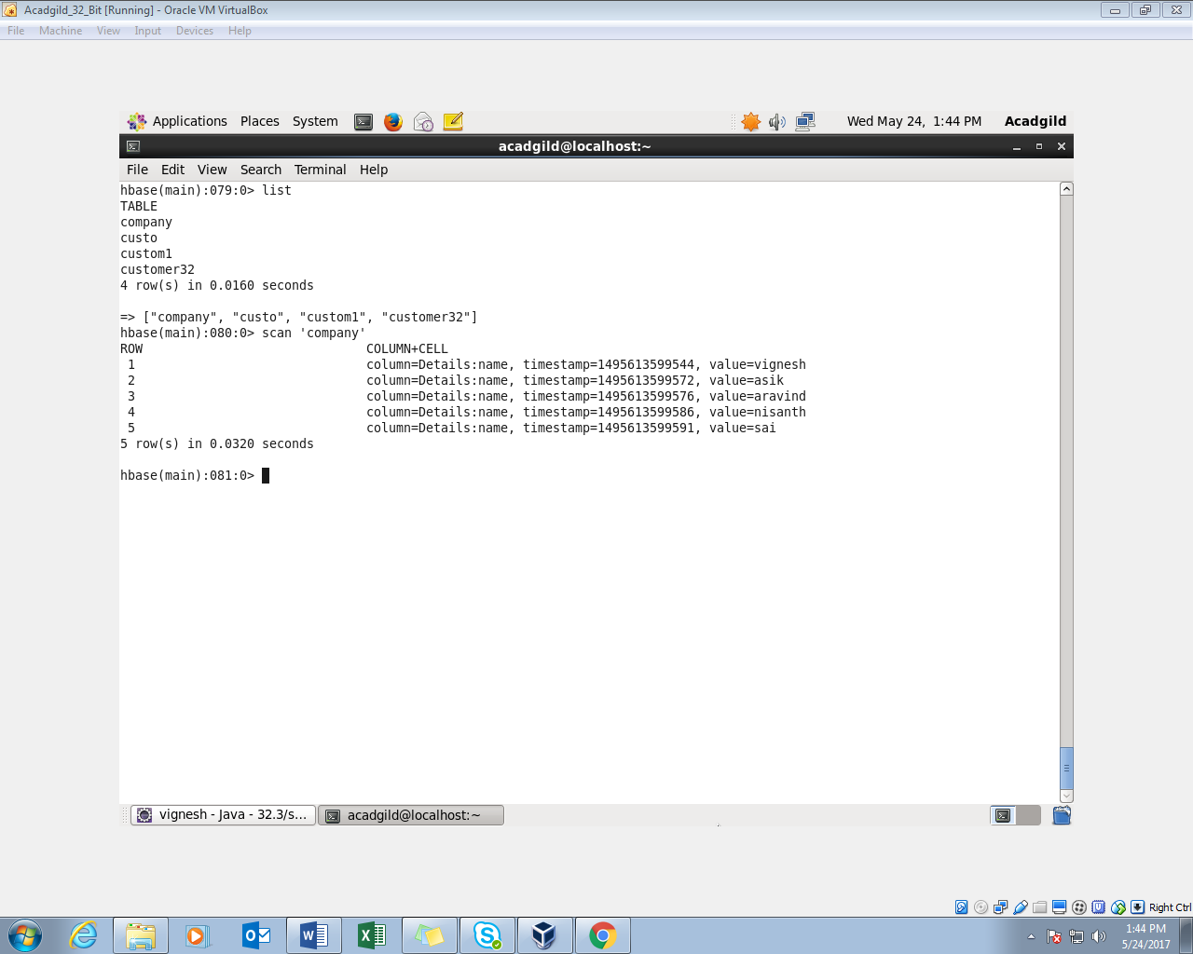

QUESTION 2 : Create the method name display and use scan class to display all records from company table.

Step 1: Write a java code by using scan class to display all records from company table.

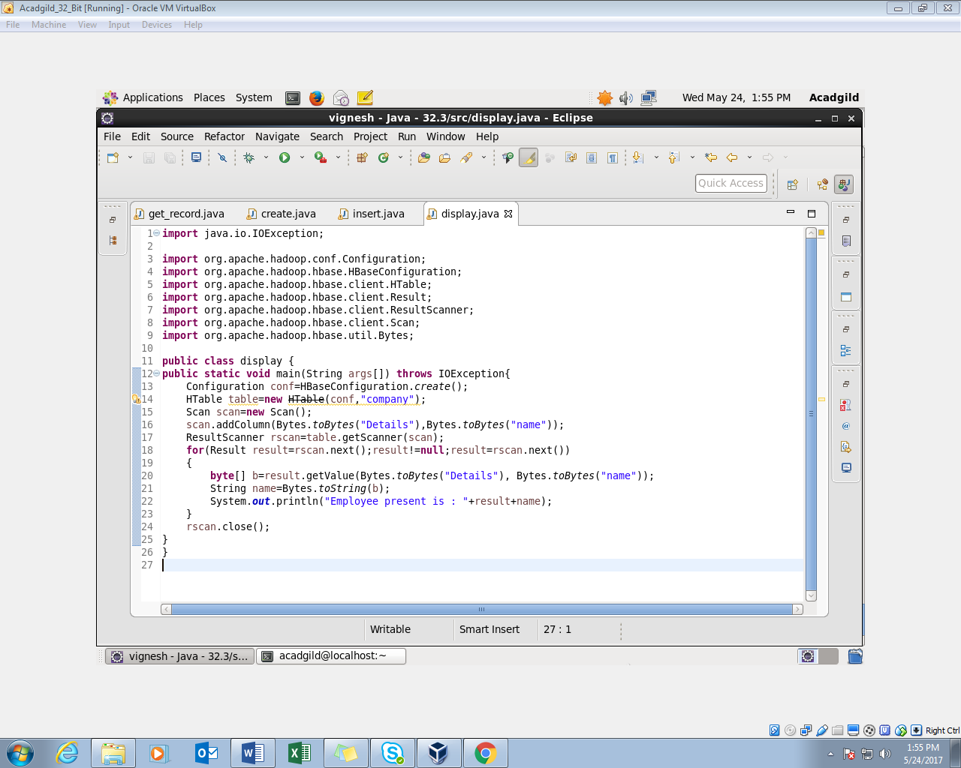

Step 2: Run java code(run as application) in eclipse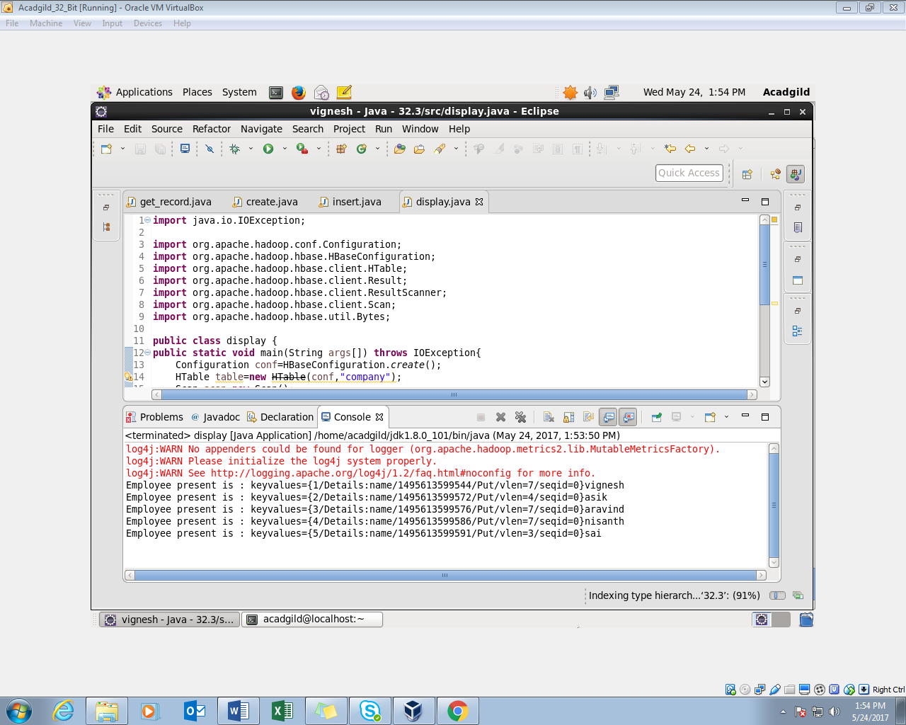

Step 3: check the contents of the table “company” using get command

